**Name: Ayush Agrawal**

**Date: 08-02-2022**

**Spring Web MVC Assignments**

* 1. 1) Design and develop a Spring MVC web application as follows:

1. Create index.jsp page having one hyperlink. When user clicks on that hyperlink, it should call HelloWorldController.
2. Design HelloWorldController class that returns a view helloWorld.jsp
3. Design a helloWorld.jsp page that displays “Hello World” message.

**View Pages:**

1. **Index.jsp**

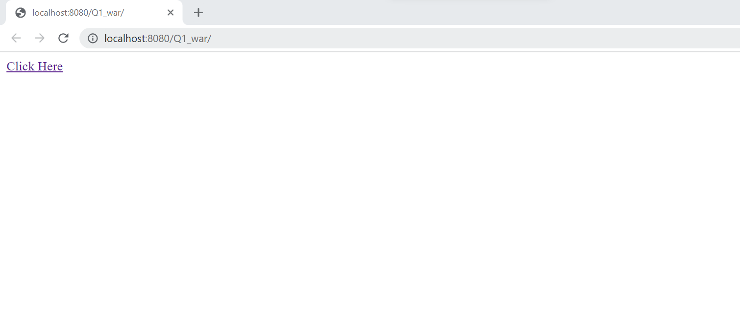

1. **Helloworld controller class**

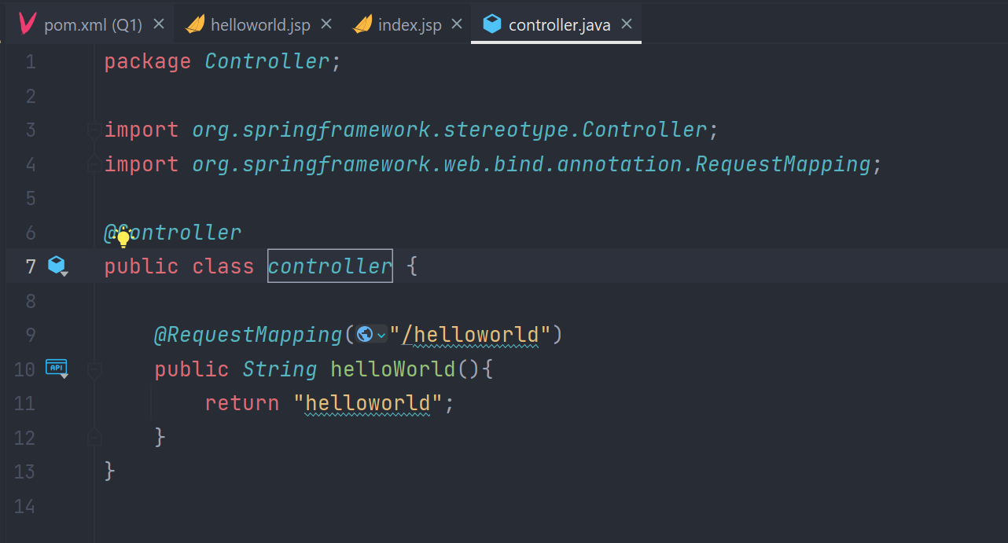

1. **Helloworld.jsp**

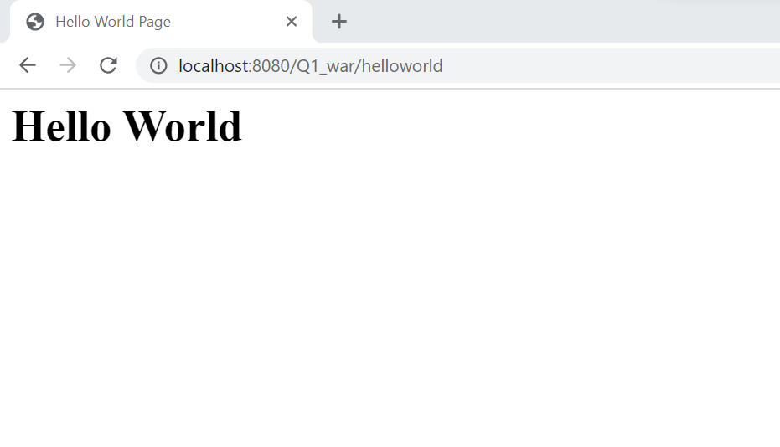

* 1. 2) Design and develop a Spring MVC web application as follows:

1. Design simpleInterest.jsp to capture principal amount, no. of years and rate of interest
2. SimpleInterestController will receive these inputs and calculates simple interest.
3. SimpleInterestController should return a view that contains simple interest.
   1. **Answer:**

**Index.jsp**

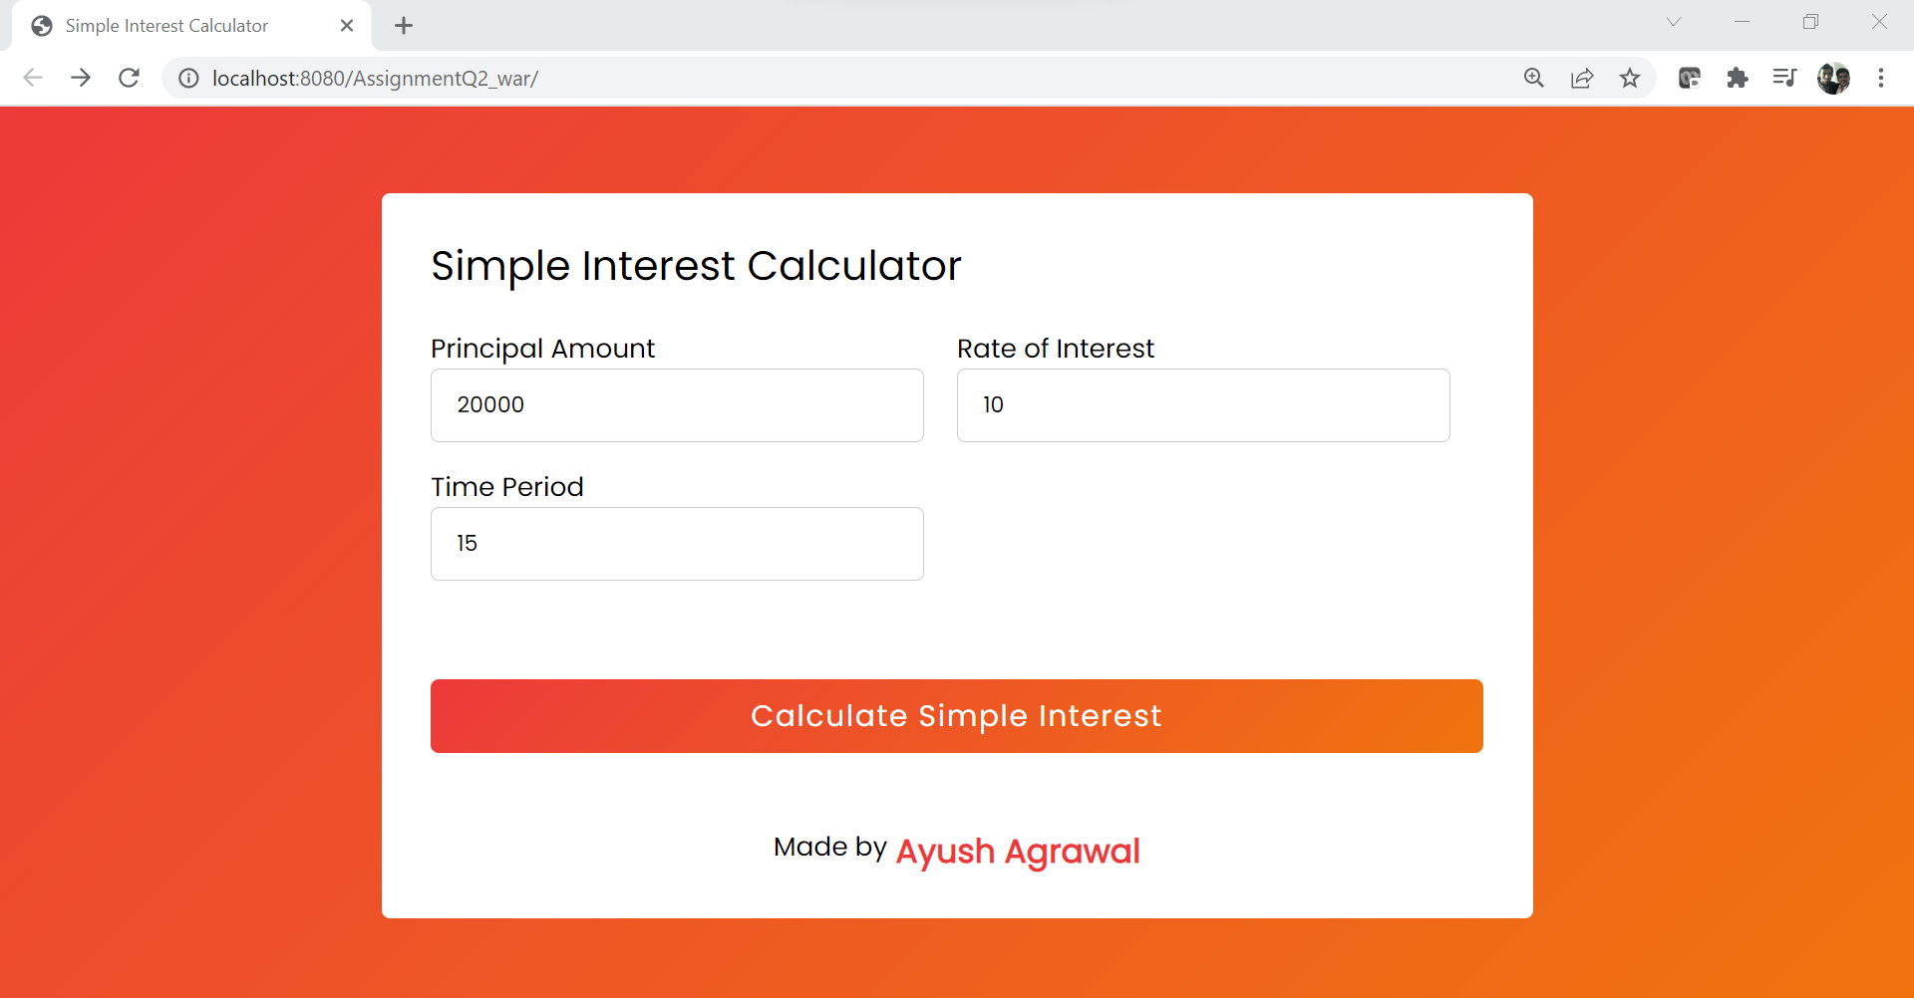

**SimpleInterestController**

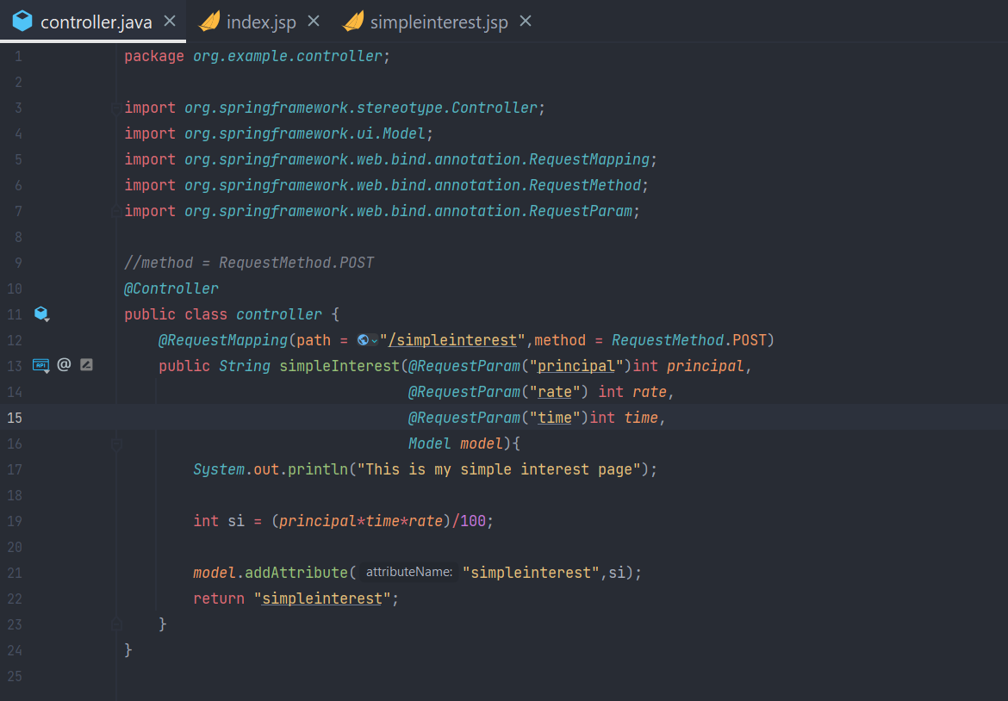

**Simpleinterest.jsp**

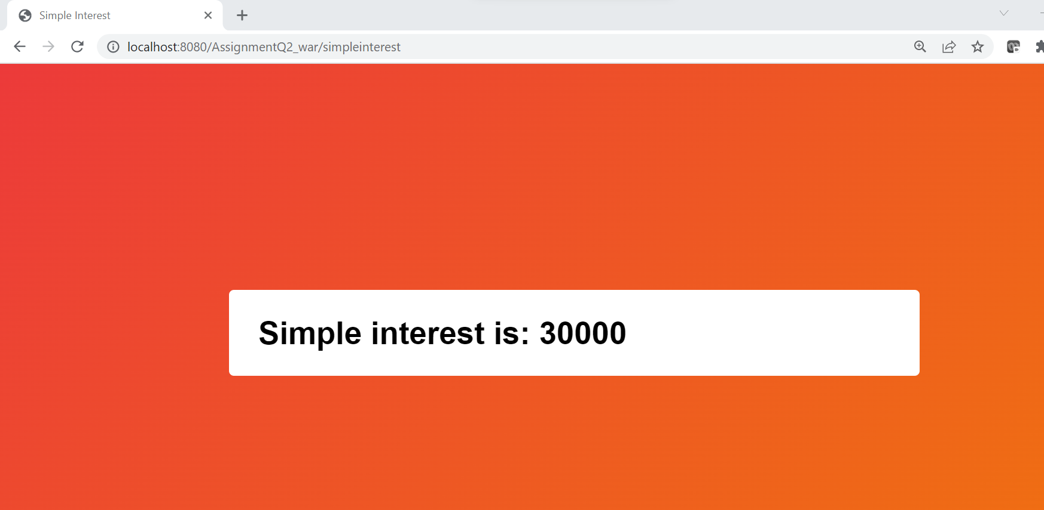

* 1. 3) Design and develop a Spring MVC web application as follows:

1. Design a User model class having attributes username, password & email.
2. Design login.jsp to capture username and password (Use ModelAttribute)
3. UserController should receive the credentials and return “success” view if user is authenticated successfully, else return “error” view.
4. Design success.jsp and error.jsp.

**Answer:**

**UserModel.java**

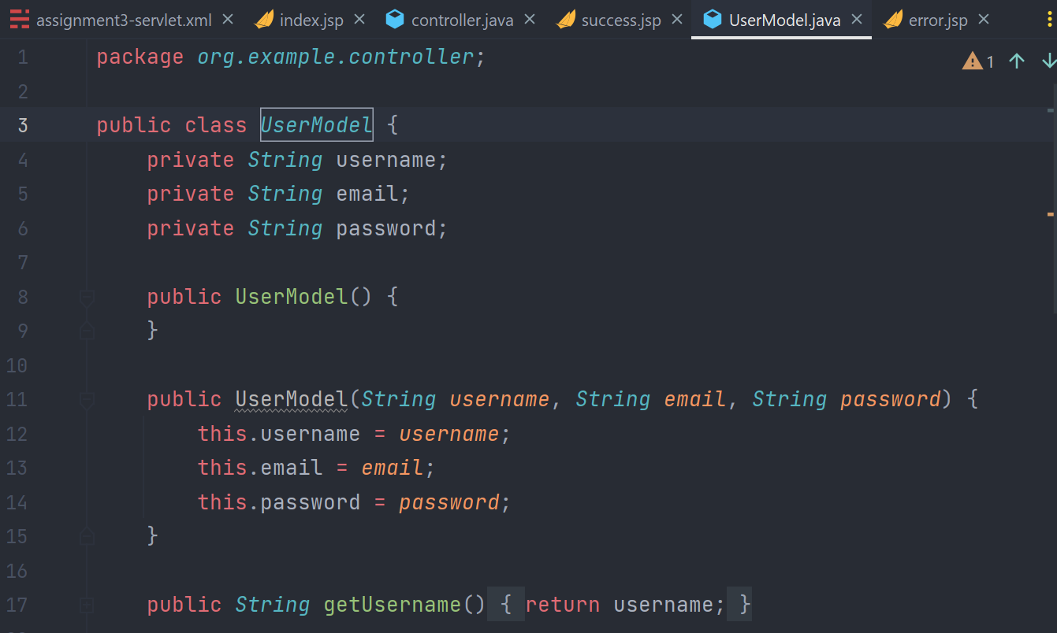

**Index.jsp**

* 1. 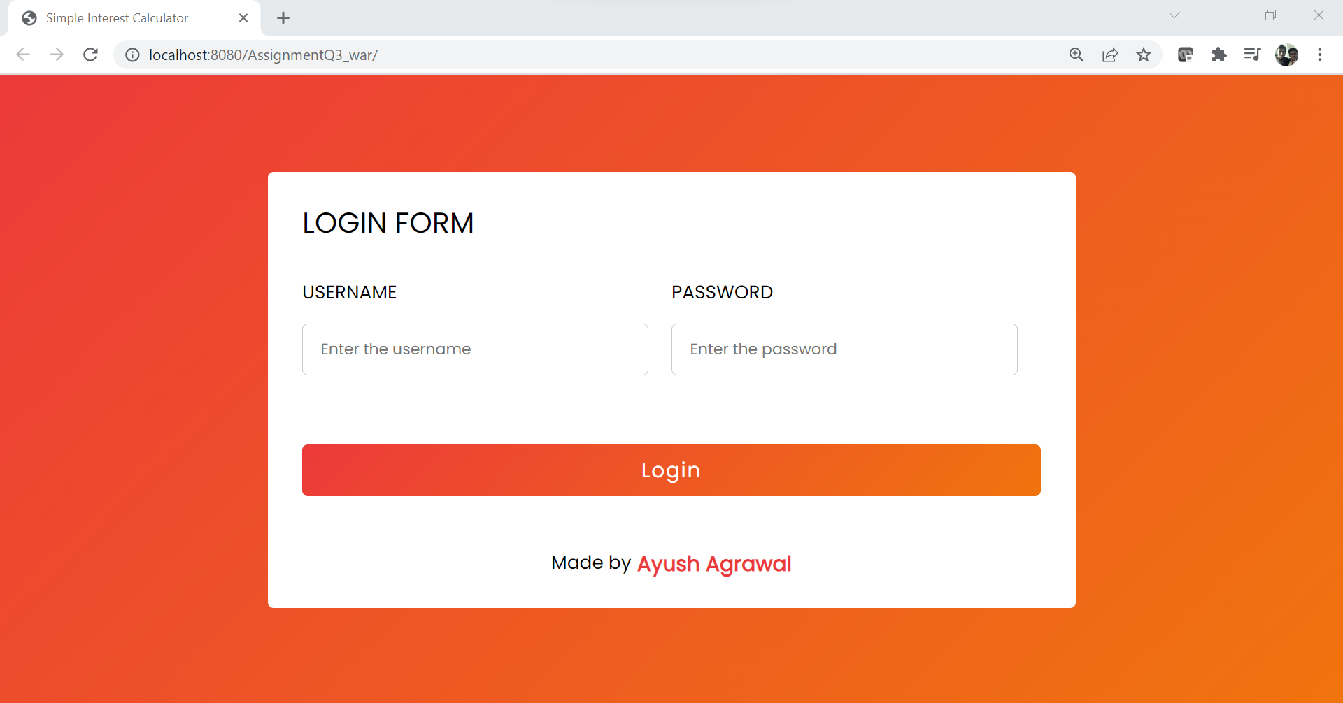
  2. **Error.jsp**

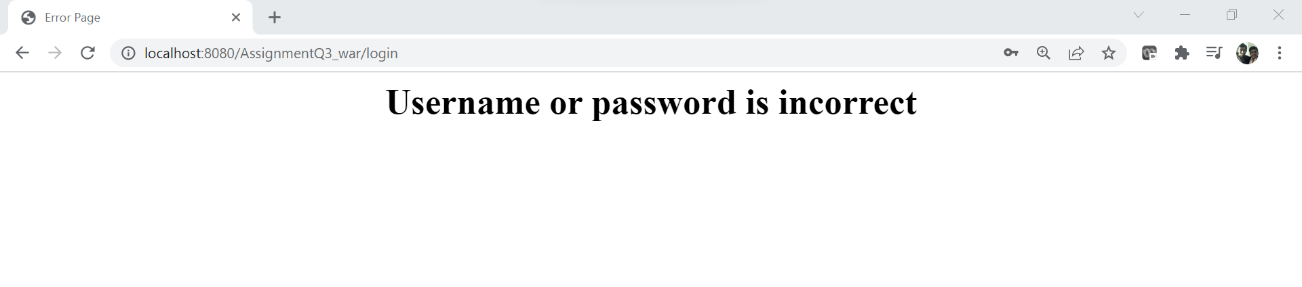

**Success.jsp**

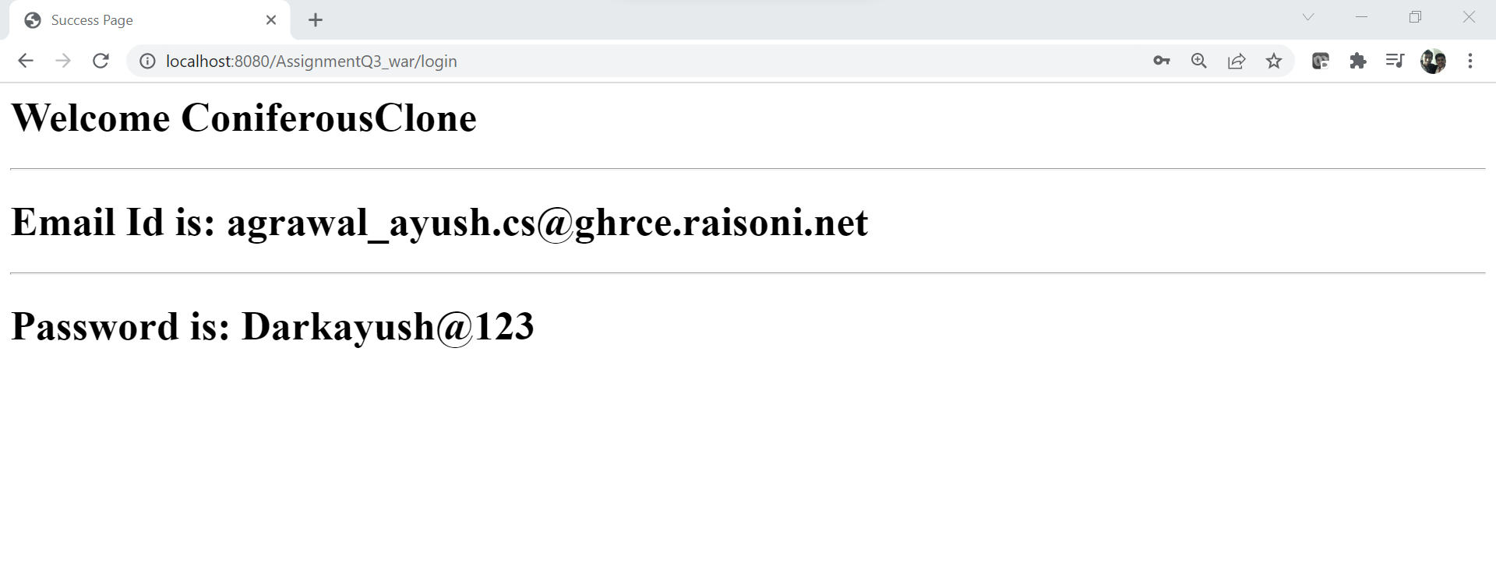

* 1. 4) Design and develop a Spring MVC web application as follows:

1. Design a User model class having attributes username, password & email.
2. Design registration.jsp to capture username, password and email. (Use ModelAttribute)
3. UserController should receive the details and store into a database. (Use JdbcTemplate). After successful registration, it should return login view.
4. Design login.jsp to capture username and password (Use ModelAttribute)
5. UserController should receive the credentials and return “success” view if user is authenticated successfully, else return “error” view.
6. Design success.jsp and error.jsp

**Answer**

**Registration.jsp**

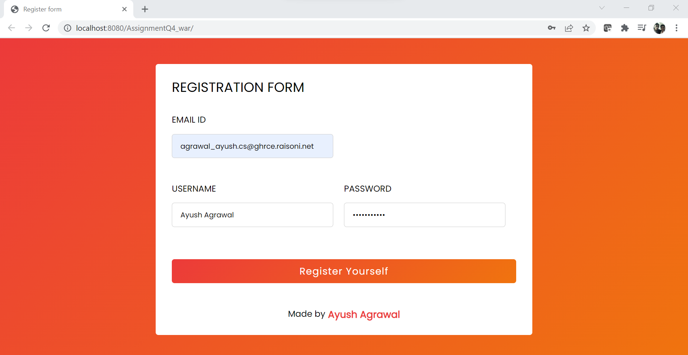

**Registration success page**

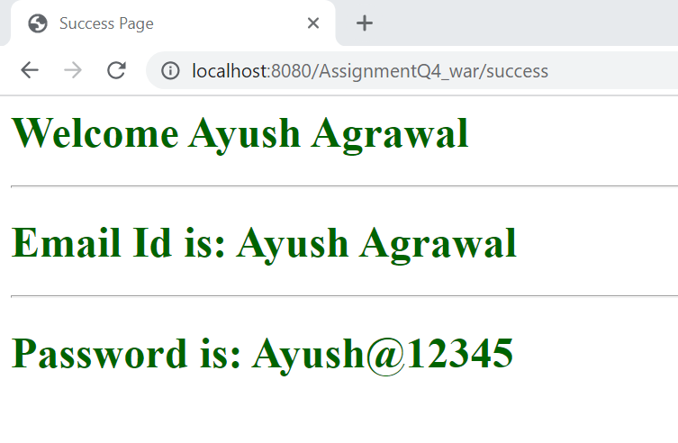

**Index.jsp**

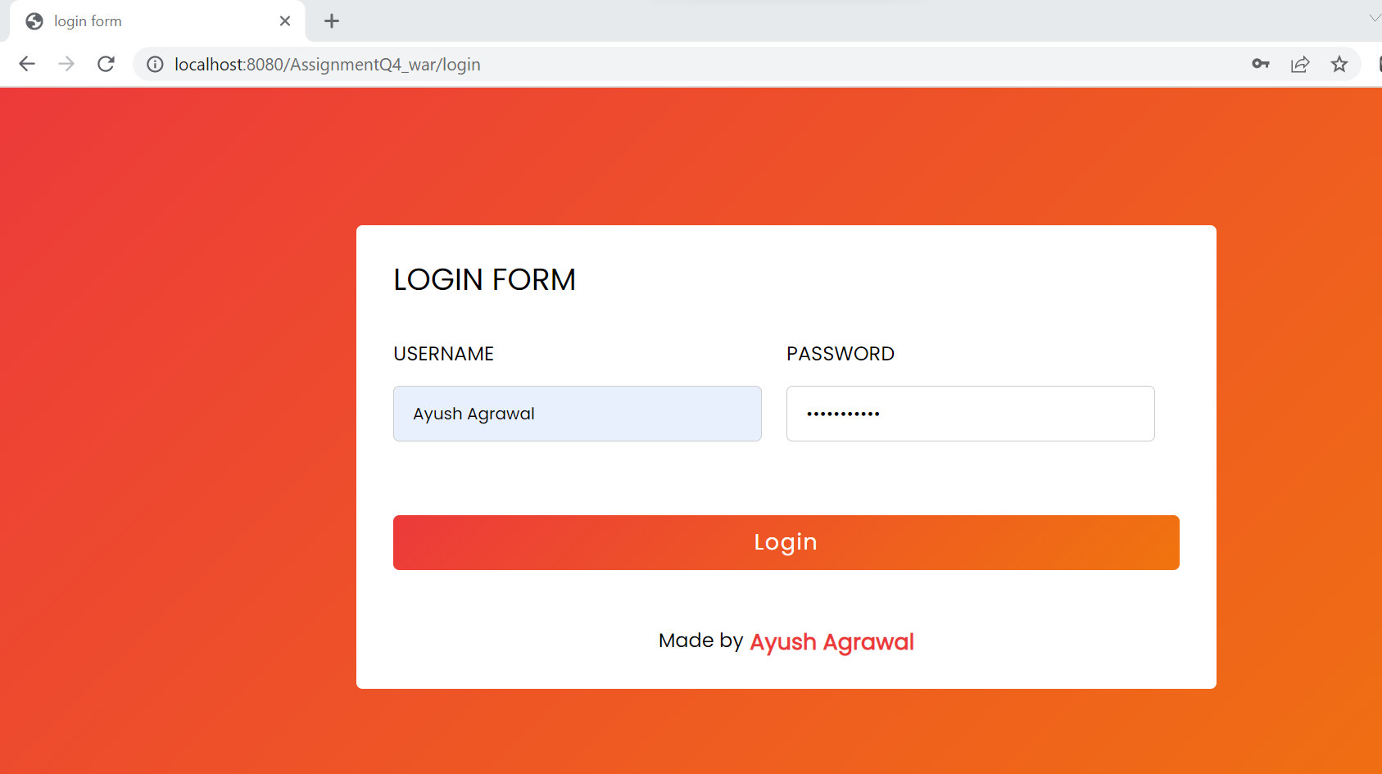

**Login success**

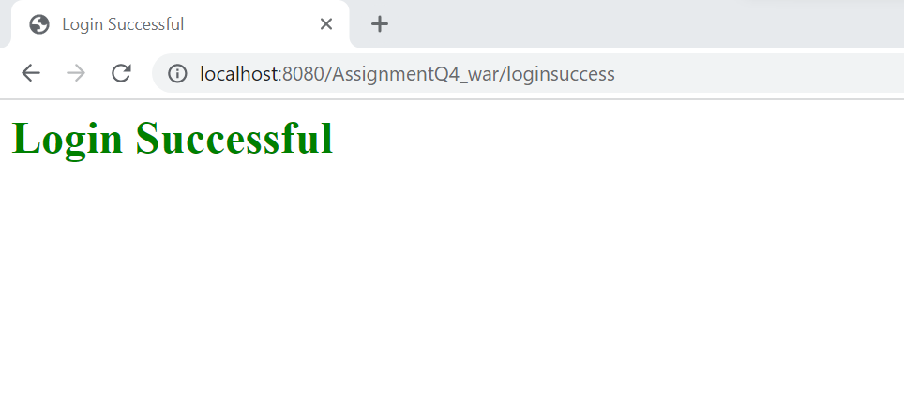

**Login error**

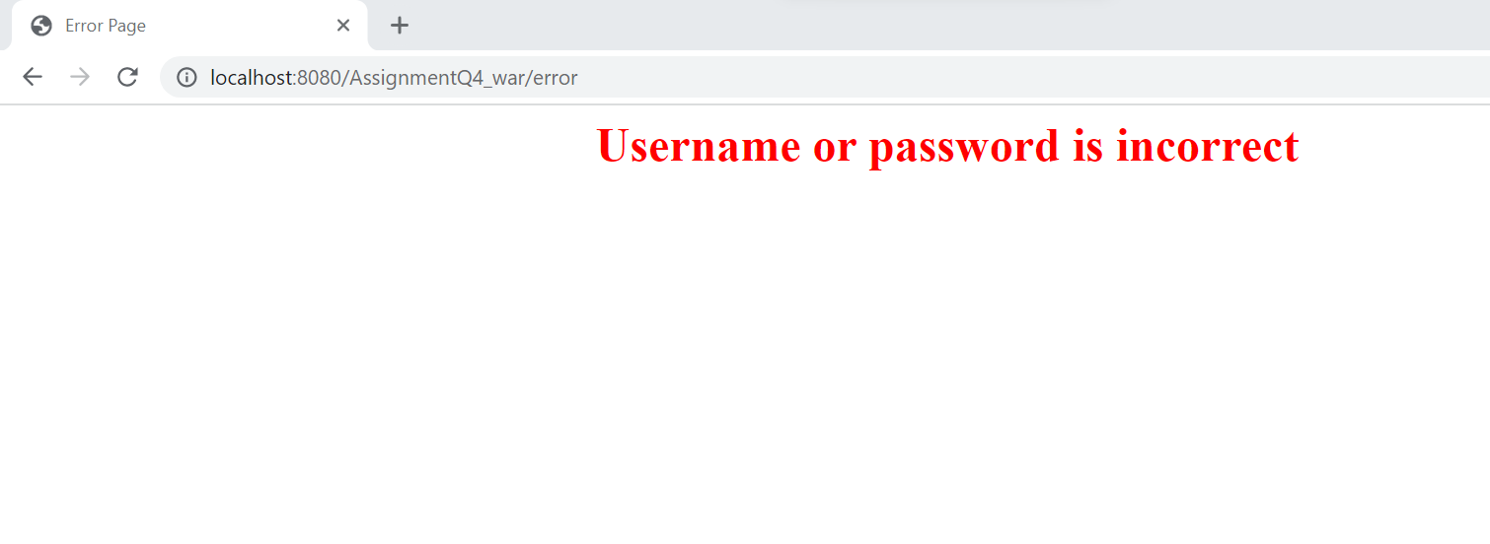

5) Develop an "Employee Management System" that manages the information about employees

1. Add a new employee

2. Searching for specific employee

3. Deleting an existing employee

4. Finding all employees

5. Editing/updating employee information.

**1. Add a new employee**

**2. Searching for specific employee.**